DEVELOPMENTAL LANGUAGE DISORDER

How we can improve outcomes for young people with Dld
Developmental Language Disorder (DLD):
A condition causing significant problems with language. DLD is one of the major forms of Speech Language and Communication Needs (SLCN). DLD begins in childhood, continues throughout adulthood, and has no known cause.

The following briefing document explains what DLD is and makes recommendations for secondary school teachers.

It is estimated the 7.6% of the UK population have Developmental Language Disorder (DLD). This means approximately 2 children in every class of 30 could have DLD.

DLD has a significant impact on everyday functioning.
- DLD makes it hard to understand what others are saying.
- It can be hard to learn new vocabulary.
- It can be hard to express one’s thoughts and needs using language.
Many people with DLD also show differences in their attention, sensory processing, movement, and reading/writing skills. A high proportion of people with DLD have an additional diagnosis of:
-ADHD (Attention Deficit Hyperactivity Disorder)
-Developmental Coordination Disorder (also known as Dyspraxia)
-Dyslexia
With no support, it can be hard for young people to cope with the demands of school. However, with the right support, young people with DLD can access their curriculum and thrive in their daily lives.
www.engage-dld.com

Common signs of DLD
-Slow response to instructions Does not understand instructions or waits for peers to respond before acting.
-Appears disengaged Seems to be uninterested or unwilling to participate in learning. Could be seen as “misbehaviour”.
-Difficulty maintaining focus Young person is restless and easily distracted.
-Finds reading and writing hard Struggles with school work.

What can I do to support young people with DLD?
What if I suspect a student has DLD?
A Speech and Language Therapist is qualified to diagnose and support people with DLD. Teachers who are concerned about a pupil may be able to make a direct referral to their local NHS Speech and Language Therapy team.
To support young people with DLD to thrive, teachers can make changes in their classrooms:
Pre-teach new vocabulary | Before teaching new topics show students any new words. Place these somewhere visible, for students to refer to later.
Use short sentences | Break your instructions down into smaller parts. This makes it easier to retain the information.
Reduce background noise | Less noise makes it easier to hear what others are saying, which facilitates language comprehension.
Explain what you mean in different ways | Give examples and show what you mean.
Use visuals | Images provide additional information, which helps with comprehension.
Adapt maths problems | Language is used in maths questions. Ensure students understand the questions being asked.
Repetition | Return to new concepts more than once.
Give time to answer questions | It can take people with DLD longer to express their thoughts. Listen carefully and allow plenty of time when they are speaking.
Support social and emotional development | Young people with DLD are vulnerable to bullying. Ensure that young people with DLD have a trusted adult in school who can provide pastoral care and advice.
Adjust homework | Be mindful that it will take children with DLD longer to complete homework. Ensure homework instructions use simple language. Check-in on young people to see how they are coping.
DLD affects everyone differently. One of the best ways to work out what support to provide is to speak to the child themselves. Ask them about what they find helpful when they are at school.

“Everyone has the right to education…without distinction of any kind”
The Universal Declaration of Human Rights, United Nations

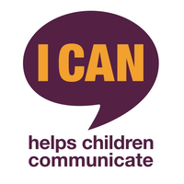
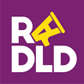
Learn more about Developmental Language Disorder:
RADLD – Raising Awareness of Developmental Language Disorder
An international campaign for DLD. RADLD organises a special DLD day annually. They provide resources to raise awareness of DLD, including a wide range of films.
ICAN
The UK’s children’s communication charity. They provide services to support children with speech, language and communication needs, including two specialist schools.
Afasic
A UK, parent-led organisation, which provides information and training for parents and professionals to support families affected by speech and language impairments.
Article in The Guardian
Developmental Language Disorder: The most common childhood condition you’ve never heard of https://www.theguardian.com/science/head-quarters/2017/sep/22/developmental-language-disorder-the-most-common-childhood-condition-youve-never-heard-of

This brief is brought to you by e-dld
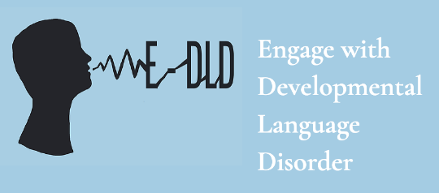
ABOUT US: Engage with Developmental language Disorder (E-DLD) was co-founded in 2019 by Dr Michelle St Clair (University of Bath), Professor Nicola Botting (City, University of London) and Dr Jenny Gibson (University of Cambridge). We want to see an increase in high-quality research into DLD.
People with DLD or their families sign up to E-DLD forming a valuable database of people affected by DLD. The E-DLD database includes children between pre-school to secondary school age, as well as adults with DLD.
E-DLD connects individuals affected by DLD to research by:
  - Creating easy-to-read research summaries about DLD.
  - Hosting parent and professional events.
  - Collating information about families with DLD over time.
  - Establishing a database of families for high-quality research.

You can support E-DLD by:

1) Visiting the easy-read research summaries on our website
2) Telling your colleagues about E-DLD
3) Sharing information about E-DLD with families affected by language difficulties

For any questions, please contact E-DLD@bath.ac.uk
www.engage-dld.com

