DEVELOPMENTAL LANGUAGE DISORDER

How we can improve outcomes for young people with Dld
Developmental Language Disorder (DLD):
A condition causing significant problems with expressive and receptive language. DLD begins in childhood, continues throughout adulthood, and has no known cause.

It is estimated the 7.6% of the UK population have Developmental Language Disorder (DLD) (1). This means approximately 2 in 30 people could have DLD.

DLD has a significant impact on everyday functioning.
- DLD makes it hard to understand what others are saying.
- It can be hard to learn new vocabulary.
- It can be hard to express one’s thoughts and needs using language.
Many people with DLD also show differences in their attention, sensory processing, movement, and reading/writing skills. A high proportion of people with DLD have an additional diagnosis of:
-ADHD (Attention Deficit Hyperactivity Disorder)
-Developmental Coordination Disorder
-Dyslexia
Separating speech from language:
DLD can be difficult to identify. Some people with DLD have co-occurring Speech Sound Disorder, however, not all will. People can be highly talkative with clear speech articulation and still have DLD. “Language” refers to the way a system of communication (speaking, writing, making signs) is used to convey meaning.

“We know that mental health is a risk for young people with DLD and yet there’s little awareness of how these issues overlap. There’s an urgent need to address these barriers.”
Professor Nicola Botting, City, University of London
The following briefing document explains what DLD is and makes recommendations for Mental Health Professionals.

www.engage-dld.com

What can I do to support young people with Developmental language disorder?
DLD is frequently unidentified, and it is under-researched. Despite the high prevalence of DLD, between 2010 to 2019 there were fewer studies of DLD compared to ADHD, which is less common and has fewer long-term consequences (2). The cost of overlooking DLD is significant. Many long-term consequences are associated with DLD, including lower academic outcomes, lower financial literacy, and mental health difficulties. While DLD is pervasive, early intervention can help people with DLD to develop their language skills and may prevent or reduce some of these associated challenges.

Use short sentences | Break your sentences down into smaller parts. This makes it easier to retain the information.
Reduce background noise | Less noise makes it easier to hear what others are saying, which facilitates language comprehension.
Explain what you mean in different ways | Give examples and show what you mean.
Give time to answer questions | It can take people with DLD longer to express their thoughts. Listen carefully and allow plenty of time when they are speaking.
Use visuals | Images provide additional information, which helps with comprehension. Give patients written documentation, containing key information discussed during the appointment, to take away with them. Ideally this should be in easy to read format.
Important note: DLD is a heritable condition (3). When a young person has DLD, their parent might also have DLD. Therefore, following the above steps for appointments with young people who have DLD can also support their accompanying parents.

To support people with DLD who access your services:
It is our collective responsibility to ensure that the needs of people with DLD are recognised by public services and to ensure that people with DLD can access the appropriate support.
Mental health professionals can support young people before a language disorder is identified by recognising the signs of DLD and directing the patient to the appropriate services.
A Speech and Language Therapist (SLT) is qualified to diagnose and support children and adults with DLD. Clinicians can signpost families concerned about their child’s language development to SLTs. Their local NHS SLT service, or a private practitioner, may be able to help.
See the Association of Speech and Language Therapists in Private Practice for more information: https://asltip.com/.
Help to identify DLD:

Learn more about Developmental Language Disorder:
RADLD – Raising Awareness of Developmental Language Disorder
An international campaign for DLD. RADLD organises a special DLD day annually. They provide resources to raise awareness of DLD, including a wide range of films.
ICAN
The UK’s children’s communication charity. They provide services to support children with speech, language, and communication needs, including two specialist schools.
Afasic
A UK, parent-led organisation, which provides information and training for parents and professionals to support families affected by speech and language impairments.
Research article: Bishop DVM, Snowling MJ, Thompson PA, Greenhalgh T, CATALISE consortium (2016) CATALISE: A Multinational and Multidisciplinary Delphi Consensus Study. Identifying Language Impairments in Children. PLoS ONE 11(7): e0158753. doi:10.1371/journal.pone.0158753
This article outlines the current criteria used to identify and classify DLD.

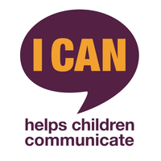

This brief is brought to you by e-dld
ABOUT US
Engage with Developmental language Disorder (E-DLD) was co-founded in 2019 by Dr Michelle St Clair (University of Bath), Professor Nicola Botting (City, University of London) and Dr Jenny Gibson (University of Cambridge). We want to see an increase in high-quality research into DLD.
People with DLD or their families sign up to E-DLD forming a valuable database of people affected by DLD.
E-DLD connects individuals affected by DLD to research by:
  - Creating easy-to-read research summaries.
  - Hosting parent and professional events.
  - Collating information about families with DLD over time.
  - Establishing a database to help with research & policy decisions.

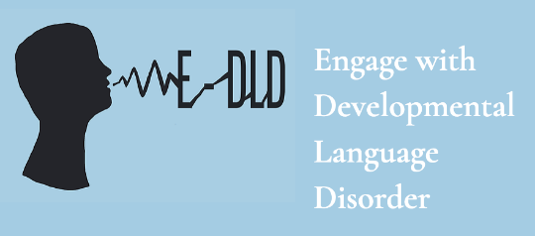

YOU CAN SUPPORT E-DLD BY:

1) Visiting the easy-read research summaries
2) Telling your colleagues about E-DLD
3) Sharing information about E-DLD with families affected by language difficulties

(2) McGregor, K. (2020), https://doi.org/10.1044/2020_LSHSS-20-00003
(3) Bishop, D. V. M., & Hayiou-Thomas, M. E. (2008), https://doi.org/10.1111/j.1601-183X.2007.00360.x
For any questions, please contact E-DLD@bath.ac.uk
References:
(1) Norbury, C. F., Gooch, D., Wray, C., Baird, G., Charman, T., Simonoff, E., Vamvakas, G., & Pickles, A. (2016), https://doi.org/10.1111/jcpp.12573
www.engage-dld.com

